Network Science Individual Assignment Report – Alexandra Catherine Gort

Data: Undirected graph with 51 nodes and 110 edges (without any self-loops and one connected component).

1 Connectivity and structure: Observed model: The observed model shows an elongated structure with dense blocks that are held together by a few links and no obvious hubs can be detected. The following measurements were observed:
Density 0.086 Mean degree 4.31 Diameter 12
Radius 6 Centre node: 25 Mean shortest path 5.04.
There are no articulation points or bridges, but removing just the two edges 11–12 and 26–27 splits the network into a lower and upper half with 35 and 16 nodes respecitvely.
In the degree-preserving null model the mean path is 2.80 ± 0.03 and the diameter 5–6; In the observed network 31 % of all node pairs are ≥ 7 steps apart, compared to in the null none.
The network is not compact but stretched out, and it hangs together at a narrow neck, although no single node or edge disconnects it.

2 Important nodes: Betweenness is highest for node 8 (0.44), node 25 (0.43), node 26 and 36 (0.38) and 27 (0.37); Closeness for 8, 25, 36, 26, 23; Eigenvector centrality for 43, 35, 33, 47, 20; nine nodes tie at the maximum degree 6. PageRank almost reproduces degree (Spearman 0.92), whereas betweenness and eigenvector centrality are only weakly related (0.26).
Different notions of importance select different nodes. Node 25 is the centre and appears in the top 5 of four measures. The nodes 8, 26, 36, 27 are in the middle on the chain between the two halves (degree 4–5) and not hubs. The eigenvector centrality instead selects the dense block in the upper right and ignores the chain (node 27: betweenness 0.37, eigenvector centrality 0.01). In an undirected, connected network PageRank adds only very little to degree.
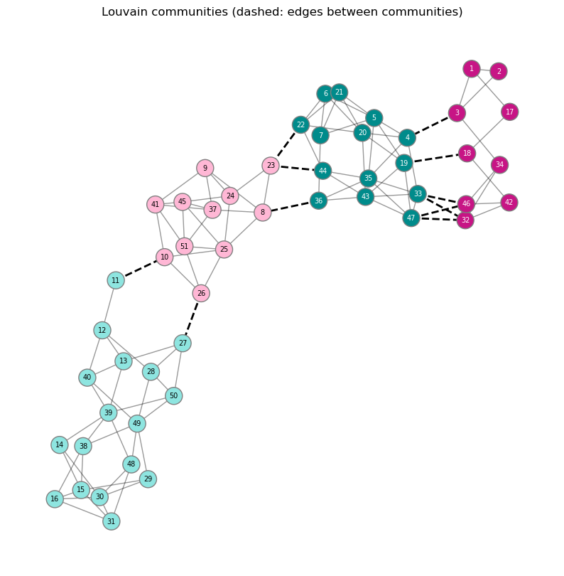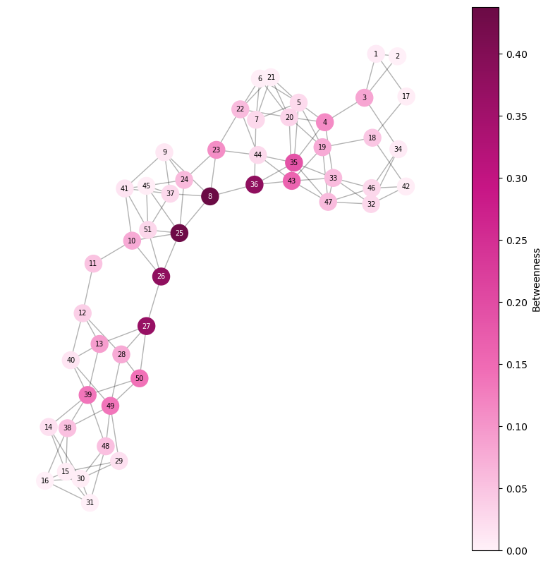
Figure 1. Four Louvain communities (best of 40 runs) arranged in a row; dashed edges connect different communities. Figure 2. Betweenness Centrality: the brokers 36, 8, 25, 26, 27 form a chain through the neck.

3 Degree structure: Obs. Degrees lie only between 2 and 6; 23 of 51 nodes have degree 4 (Fig. 2c). Meas. Variance 1.18, i.e. variance/mean = 0.27 (Poisson: about 1). A Poisson distribution with the same mean would give about 4 nodes of degree 0–1 and about 7 of degree ≥ 7; there are none. Interp. The mean of 4.3 alone would also fit a network with hubs; the distribution shows the opposite: a very homogeneous network, even narrower than a random one.

4 Connected nodes: Meas. Degree assortativity r = 0.169 versus −0.021 ± 0.096 in the degree-preserving null (z = 1.98, empirical p = 0.02). The mean neighbour degree rises from 3.50 (k = 2) to 4.06 (k = 3) but is flat for k ≥ 4 (4.64–4.70, null ≈ 4.6). Interp. There is only a weak, borderline tendency to connect to similar degrees, carried by low-degree nodes at the periphery; otherwise edges are formed almost independently of degree, so the network is not organised around hubs.

5 Local structure. Meas. 32 triangles, mean clustering 0.238, transitivity 0.244, versus 8.0 ± 2.6 triangles and clustering 0.061 ± 0.022 in the degree-preserving null (none of 200 reaches 32; G(n,m): 0.081). 40 of the 110 edges are in no triangle, including both neck edges 11–12 and 26–27. Nodes 33 and 47 (degree 6) lie in 5 triangles each (clustering 0.33), while 39 and 49 (also degree 6) have 0.07; the broker 36 (degree 4) has clustering 0 and node 8 has 0.1. Interp. Neighbours of a node are connected about four times more often than the degrees explain: the network consists of tightly knit local neighbourhoods. Links between neighbourhoods close no triangles, so brokers have clustering near zero.

6 Communities: Obs. Four dense regions follow each other from the upper right to the lower left (Fig. 1a). Meas. Louvain (40 runs) gives Q = 0.608–0.625 (mean 0.615) and 4 or 5 groups per run (22 and 18 runs); the best partition has groups of 9, 14, 11, 17 nodes and only 11 of 110 edges between groups. Degree-preserving randomisations reach only Q = 0.408 ± 0.018 (maximum 0.461). Interp. The structure is convincing, because even the weakest of the 40 runs exceeds the strongest of 200 random networks, but the exact number of groups (4 or 5) and the boundary nodes are not unique. The lower group (11–16, 27–31, 38–40, 48–50) is attached by only 10–11 and 26–27; the middle and upper groups are linked by 22–23, 23–44, 36–8; the nodes 11, 23, 32, 46 have half of their neighbours in another group.

7 Random, small-world or scale-free? Meas. Observed values against the models (mean of 100 networks each, ring lattice deterministic; ring lattice and Watts–Strogatz have 102 instead of 110 edges):
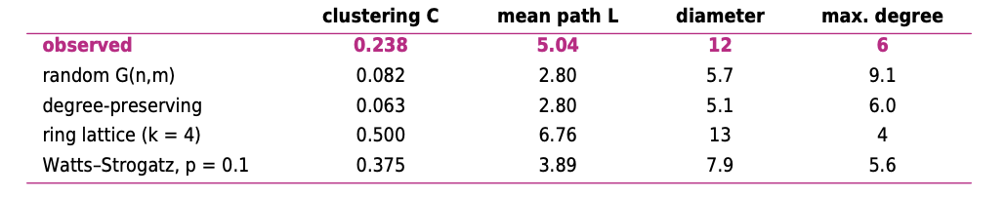

Interp. Not random: clustering is 2.9 times and the mean path 1.8 times that of a random graph. Not small-world: σ = 1.61 and ω = 0.08 would formally hint at it, but the small-world idea (Lecture 4) is distances almost as short as random together with lattice-like clustering, and our paths are almost twice the random ones (ln n / ln⟨k⟩ = 2.7 vs. 5.04). No rewiring probability reproduces both measures (Fig. 2e): our clustering (0.48 of the lattice value) corresponds to p ≈ 0.25, where the path would be only about 3.2; our path (0.75 of the lattice value) to p ≈ 0.03, where clustering would still be 0.93. Not scale-free: the maximum degree is 6 (1.4 times the mean), below the 9.0 of random graphs (none of 200 random graphs has ≤ 6), and there is no tail. The network is closest to the lattice-like end of the Watts–Strogatz model, between lattice and random.

8 Beyond the summary: a chain of blocks. Mean degree, density, clustering and the absence of bridges do not reveal that the network is almost one-dimensional. Meas. (i) Treating the four communities as nodes gives a path 0–1–2–3 with thinning links of 6, 3 and 2 edges. (ii) The distances of all nodes to the two ends of a longest path (nodes 2 and 15) are almost perfectly anti-correlated (r = −0.974), and for 50 of 51 nodes the detour 2 → v → 15 costs at most 2 extra steps compared with the direct shortest path (Fig. 2f); the communities follow each other along this axis (mean distance from node 2: 2.1, 3.6, 6.3, 10.2). (iii) The algebraic connectivity λ2 (small if a network is easy to cut in two) is 0.048 versus 0.777 ± 0.104 in 200 degree-preserving randomisations (minimum 0.388). Interp. This explains the long distances (diameter 12), the high betweenness of 25, 26, 27, 8, 36, and why everything travelling between the two ends must pass the necks, e.g. 10–11 and 26–27 for the lower block.
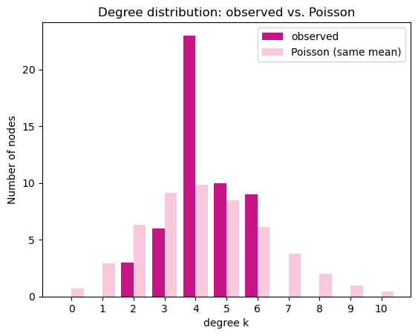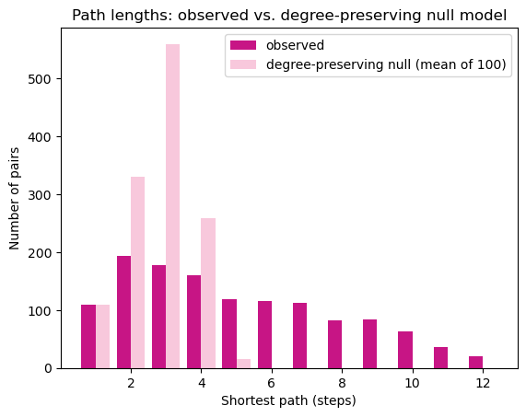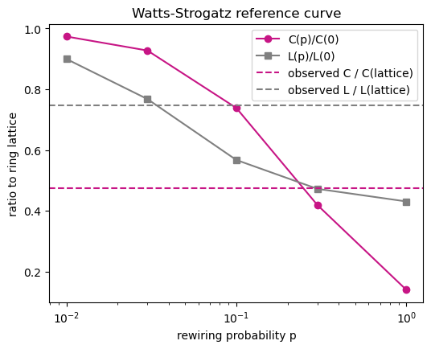
Figure 3. Degrees vs. Poisson with the same mean. Figure 4. Path lengths vs. the degree-preserving null. Figure 5. Watts–Strogatz reference curve; dashed lines: observed ratios of our network.

